**CARTESIAN JOIN**

It is based on **Cartesian product theory.**

**Cartesian Product Theory in Mathematics states that :-**

Let there be two sets – A {1, 2, 3} & B {4, 5}

Thus the Cartesian product (A*B) will be,

A * B = { (1,4), (1,5), (2,4), (2,5), (3,4), (3,5) }

Thus there are 6 sets – order of A is 3 & order of B is 2.

Therefore, 2*3 = 6 is the Cartesian product.

**Ex:**

Display employee name along with the department name

Here, each and every record of the 1st table will combine with each and every record of the 2nd table.

If a table A is having 10 records & B is having 4 records – the Cartesian join will return 10*4 = 40 records.



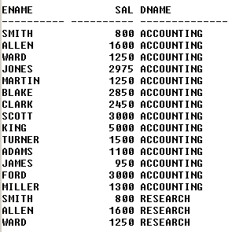 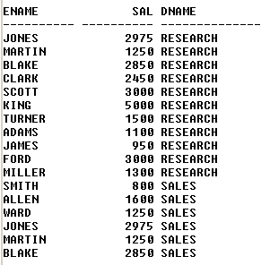

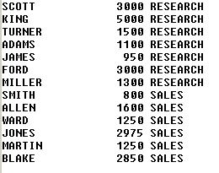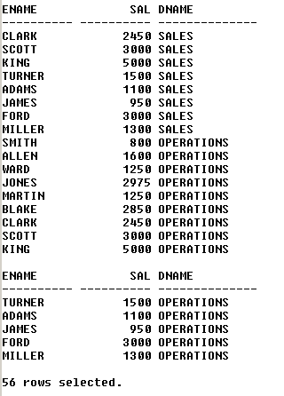

* From above – we can see that the above query returns 56 records – but we are expecting 14 records.
* This is because each and every record of employee table will be combined with each & every record of department table.
* Thus, Cartesian join should not be used in real time scenarios.
* The Cartesian join contains both correct and incorrect sets of data. We have to retain the correct ones & eliminate the incorrect ones by using the **inner join**.